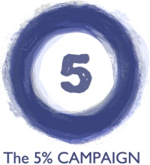
Share your story form: Self-Advocate
We would love to share your stories to help support a 5% rate increase for Home and Community Based Services in 2015! They can be a couple of sentences to a page long, and can be written by a DSP or other staff member, a person served, a family member, a volunteer, a case worker or anyone else.
Stories/quotes may be used on social media, on handouts, or in email messages. If you are submitting the story on behalf of someone, please be sure The 5% Campaign has permission to share the story. Your phone and email will not be shared, and will only be used if we have a question. Content may be edited by The 5% Campaign staff for consistency, spelling, and grammar. Please feel free to send more than one story!

My Information
Name: Click here to enter text.
☐ my full name may be used ☐ my first name may be used ☒name may not be used
Organization I receive services from: Click here to enter text.
best contact person/info for questions: Click here to enter text.

My Story
Say a little about yourself, or the daily challenges you face: Click here to enter text.

My support staff help me in the following ways: Click here to enter text.

If my services were no longer available I would not be able to: Click here to enter text.

When new support staff come and go in my life, it impacts me in the following ways: Click here to enter text.

Photo Info (please include caption if you are including photos): Click here to enter text.

Thank You!
Please email this form to 5% Communications Team member Rich Stoebe at rich.stoebe@livingwell.org or call (651) 242-5125 if he can help answer any questions.

