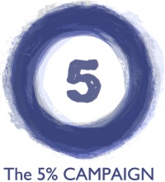
Share your story form: Caregiver
We would love to share your stories to help support a 5% rate increase for Home and Community Based Services in 2015! They can be a couple of sentences to a page long, and can be written by a DSP or other staff member, a person served, a family member, a volunteer, a case worker or anyone else.
Stories/quotes may be used on social media, on handouts, or in email messages. If you are submitting the story on behalf of someone, please be sure The 5% Campaign has permission to share the story. Content may be edited by The 5% Campaign staff for consistency, spelling, and grammar. Your phone and email will not be shared, and will only be used if we have a question. Please feel free to send more than one story!

My Information
Name: Click here to enter text.
Agency: Click here to enter text.
Phone: Click here to enter text.
E-mail: Click here to enter text.

My Story
Why did you choose to become a direct support professional/caregiver? Click here to enter text.

What about your job inspires you? Click here to enter text.

what job challenges do you face? Click here to enter text.

Why do you think a 5% rate increase is needed? Click here to enter text.

Photo Info (please include caption if you are including photos): Click here to enter text.

Thank You!
Please email this form to 5% Communications Team member Rich Stoebe at rich.stoebe@livingwell.org or call (651) 242-5125 if he can help answer any questions.

