*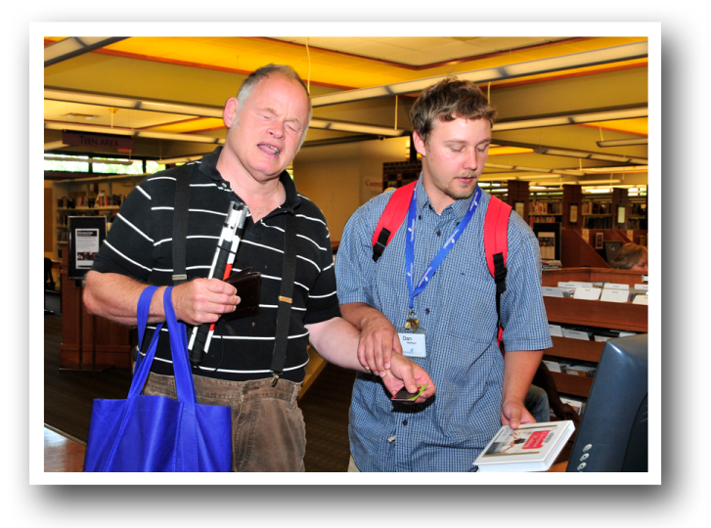­*

**MY CONTACT INFO**

**Name: _____________________________________________________________________________**

**Street, City, State, Zip: _______________________________________________________________**

**Phone/Email: _____________________________________________________________________­­­­­­__**

**ABOUT ME**

**What services do you provide? Or what services do you/your family member receive?**

**Why are these supports important? What do they mean to you?**

**Why I support the Best Life Alliance:**

**When new support staff come and go, it impacts me/my family/my organization in the following ways:**

**Many caregivers received little or**

**no wage increases over the past**

**five years.** Many work two or more

caregiver jobs to make ends meet.

These caregivers support our most

vulnerable citizens.